*Author: Dillon Frawley*

Source: https://en.wikipedia.org/wiki/List_of_countries_by_life_expectancy. Data: https://drive.google.com/file/d/1cFxsHNjolHO15AtvC74YpE9eEADOQdc/view?usp=sharing

*Visualisation 2 FIT3179*

Word Count: 1000 URL: https://dfra0004.github.io/FIT3179-Asgn2/

# Description

## Domain:

Average life expectancy and Gender Differences of each country in 2019.

## Why

The purpose of this visualisation report is to inform the readers of the average life expectancy of each country in 2019. The reader can use the visualisations and information contained in the report to learn about the countries with the highest and lowest average life expectancy and the countries with the highest and lowest differences in average life expectancy between males and females.

This visualisation report helps depict and put into perspective the means, disparities, and outliers of the world in terms of each country’s average life expectancy and difference between genders.

Tasks for the reader could entail but are not limited to looking up specific countries and browsing/exploring for outliers in the visualisations. This follows from “Lookup = location and target are known, Browse = location is known or target is unknown, Locate = location is unknown or target is known, Explore = location and target are unknown” JENNY, B (2022)

## Who

The target audience for this visualisation report is individuals interested in visual representations of the average life expectancies and gender differences for each country in the world.

## What

Author

Dillon Frawley.

### Sources

Website data was scraped from: <https://en.wikipedia.org/wiki/List_of_countries_by_life_expectancy>

Csv file: <https://drive.google.com/file/d/1cFxsHNjolHO15AtvC74YpE9eEADOQdc/view?usp=sharing>

### Creation Process

Using these sources, I web scraped the required data into a csv file. From there I added a continent column as the table (table 4) from the Wikipedia source did not contain a continent column for each country. Then I brainstormed using the five-sheet methodology and then implemented the design through visual studio code.

## Why and How

### Idiom 1:

Figure – Choropleth Map

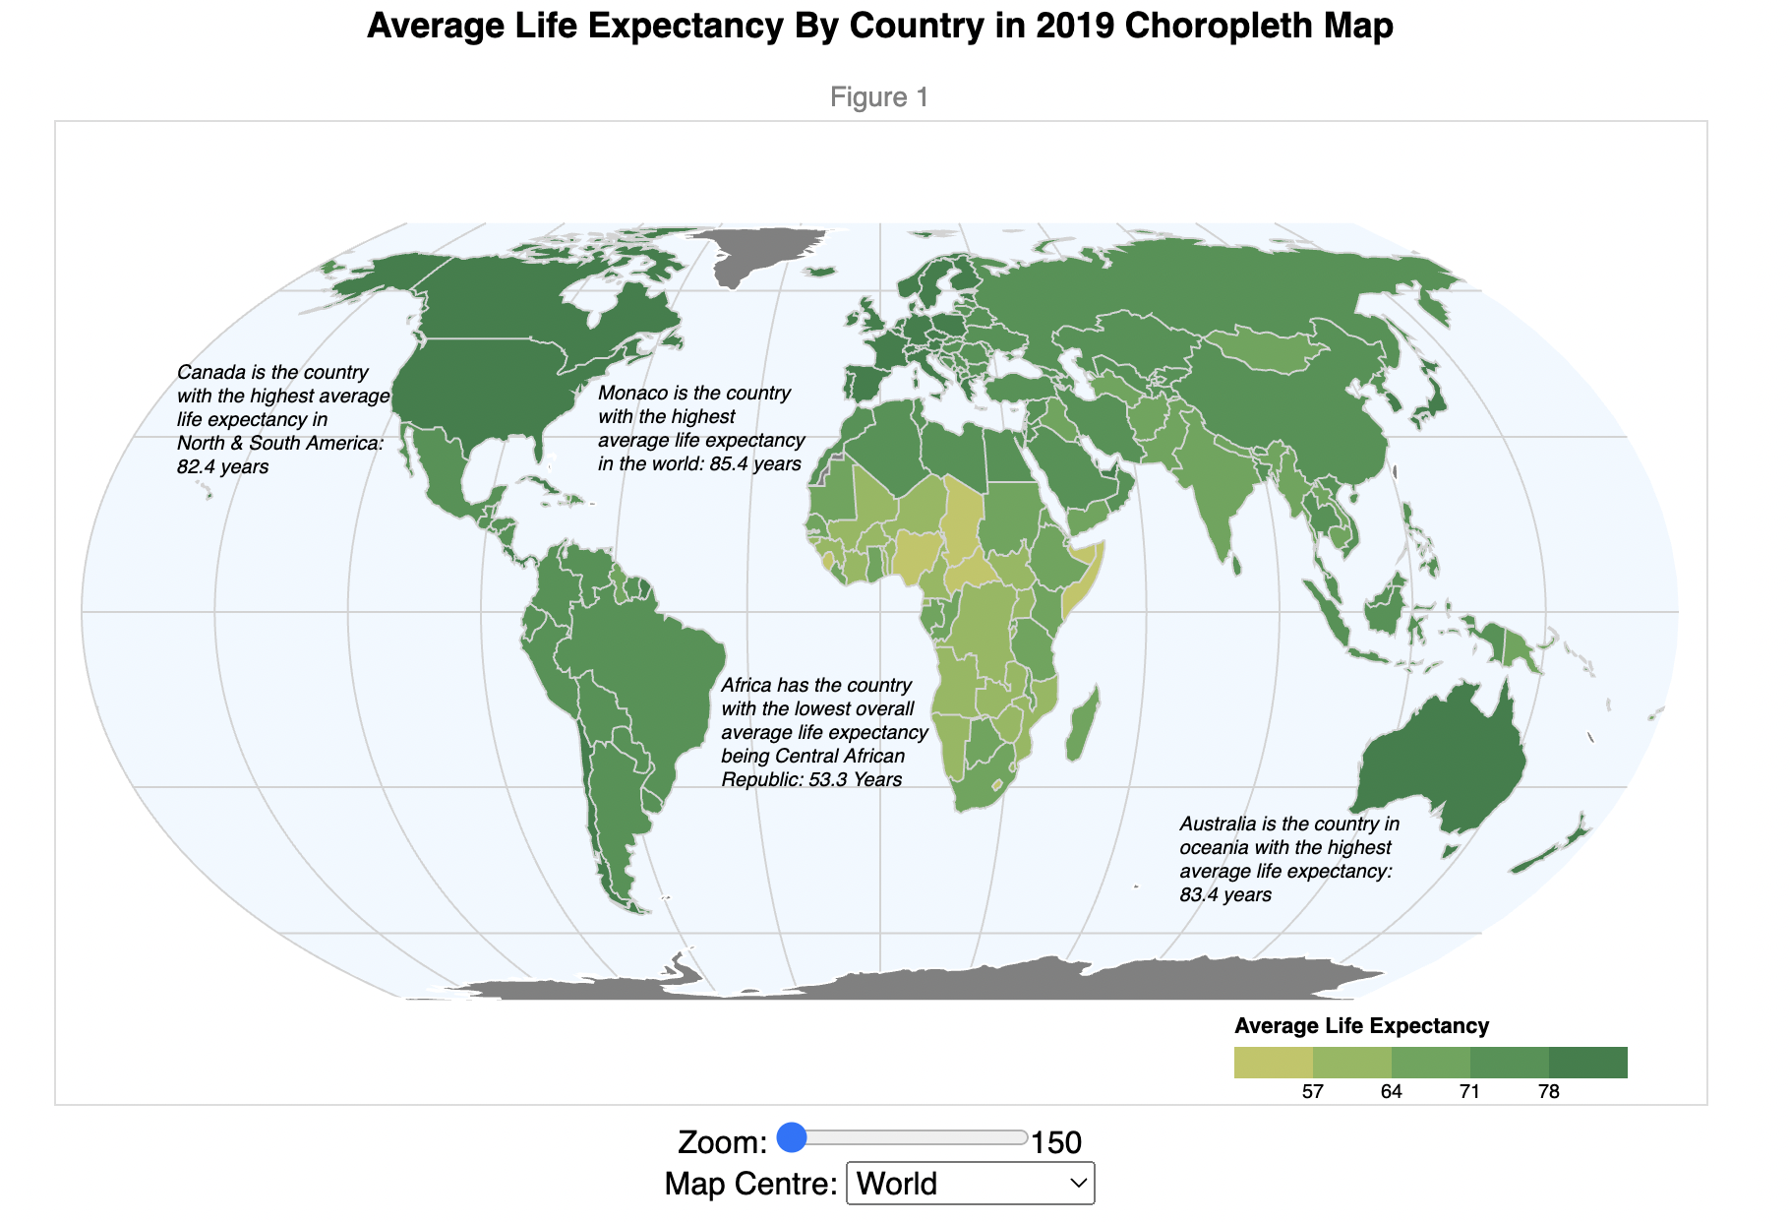

To show the average life expectancy of each country the idiom used as show in figure 1 is a choropleth map with the raw data values quantized into a five-part scale with equal number of countries in each group. The colour encoding is a luminance gold-green scale to emphasize the disparity within all countries with dark green representing the higher valued countries and gold representing the lower valued countries. The interaction encoded in this visualisation gives the reader the ability to select an origin of the map centre and allows the user to zoom to a desired value to assist in interpretation and observation of each country’s average life expectancy.

### Idiom 2

Figure – Bar Chart

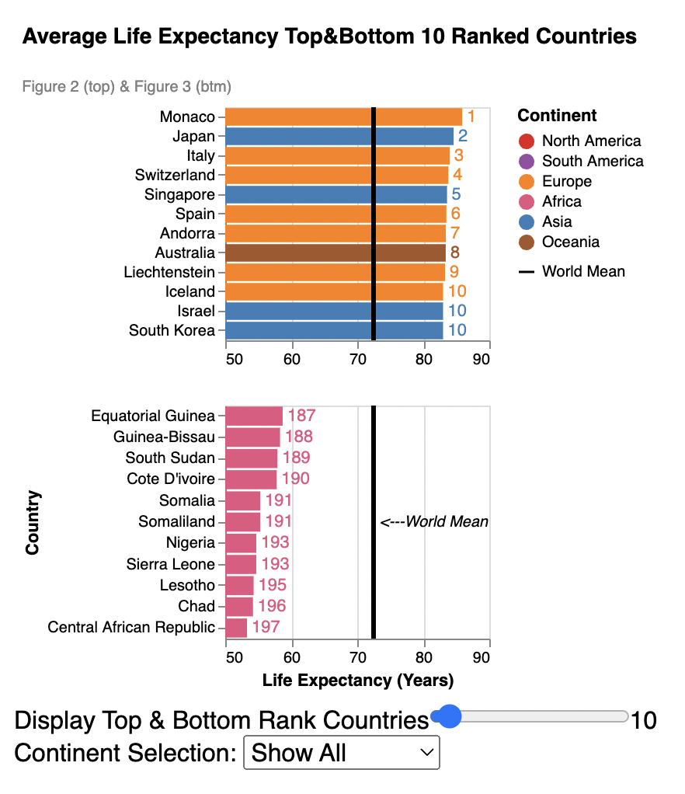

To show all the countries ranked 2 visualisations were used as shown in figure 2. The idiom used is a bar chart with the categorical/nominal attribute of country is on the y-axis and the quantitative attribute average life expectancy is shown on the x-axis. The colour encoding is a colour hue for each continent and the text annotation on the visualisation is the rank the country is positioned at the end of each bar. The interaction encoded in this visualisation allows the reader to choose a desired rank to display as an upper and lower bound on the countries in the world. The reader may also select a desired continent to filter the visualisation to display.

### Idiom 3

Figure – Choropleth Map

To show the gender difference of each country the idiom used as show in figure 3 is a choropleth map with the raw data values quantized into a five-part scale with equal number of countries in each group to follow “Generally do not map raw values, but normalise values by area if possible” JENNY, B (2022). The colour encoding is a luminance yellow-green-blue scale to emphasize the disparity within all countries with dark blue representing the higher valued countries and yellow representing the lower valued countries. The interaction encoded in this visualisation gives the reader the ability to select an origin of the map centre and allows the user to zoom to a desired value to assist in interpretation and observation of each countries gender difference.

### Idiom 3

Figure – Scatter Plot

To show the disparity of male to female life expectancy (gender difference) a scatter plot is used as shown in figure 4 with the male quantitative attribute on the x-axis and the female quantitative attribute on the y-axis. The colour encoding is the same as figure 2 with a colour hue for each country’s continent. The interaction encoded in this visualisation allows the reader to filter the lower bound of gender difference and identify the outliers in the desired range. The reader also can select a continent to filter and display as well.

### Why and How Summary

The idioms used in this visualisation report helps the reader achieve their tasks by allowing the user to search, browse and identify specific countries and values of these countries by exploring and querying the choropleth maps, rank bar charts and line chart.

The features unique to the visualisations used are allowing the reader to centre and zoom on each of the choropleth maps, choosing a desired upper and lower bound of ranks to display, choosing a lower bound for gender difference and allowing the user to choose a desired continent to display.

### Screen Capture of Entire Visualisation – Page 1

#### (Scaled over 2 pages as cannot fit in a single screenshot)

Figure – First Page Of Screen Capture Of Entire Visualisation

### Screen Capture of Entire Visualisation – Page 2

Figure - Second Page Of Screen Capture Of Entire Visualisation

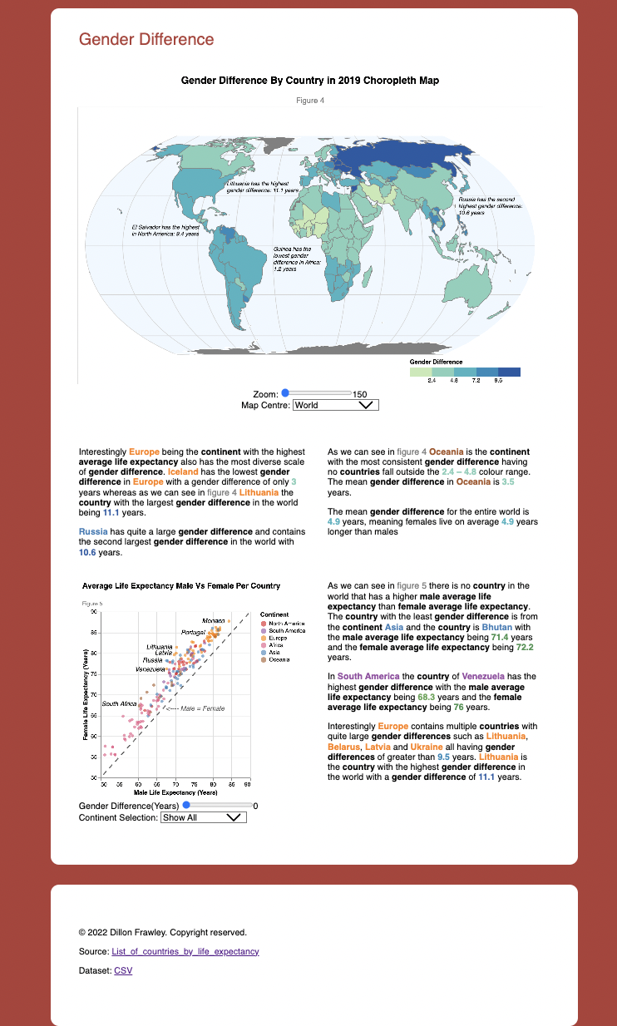

# Design

## Layout

As shown in figure 5 and 6 the text displayed for the reader in paragraphs is represented in 2 columns on either side of the middle of the page to assist symmetry in the report. When a visualisation isn’t a map, it has been positioned on the left column and the paragraph relevant to the visualisation is position in the right column.

## Colour

The colour used is a colour hue to encode each countries continent. The colour used in each choropleth map follows “Primarily luminance changes: the greater the value, the darker” JENNY, B (2022). The maps use different colour scales as to assist the reader in differentiating between the numerical values referenced in the paragraphs as followed by “Slight change in hue is possible, to increase the number of distinguishable colours” JENNY, B (2022). Each reference in the paragraphs to an attribute visualised is bolded and when related coloured to match the visualisation its represented in. The colours used also ensures no red and green colours are used as following “8% of all men have a color vision deficiency, They mainly confuse red and green (deuteranopia and protanopia)” JENNY, B (2022).

## Figure Ground

The visual centre is used to show important elements and visualisations such as the report title, map titles and map idioms as following “Graphical representation in which elements are ranked according to their importance” JENNY,B (2022). The paragraphs and remaining visualisations are shown in columns around the report centre to assist balance and symmetry.

## Typography

The type face used in this visualisation report is Open+Sans in a sans serif and open shape style to assist the reader in reading smaller text as following “Sans serif for better readability and Open shapes for better readability” JENNY,B (2022). The hierarchy of font weights is visually displayed from the most important information the main title all the way through to the least important the figure numbers. For each paragraph a max width has been implemented to ensure approximately 7 words per line.

## Storytelling

The report has been separated into pages grouping relevancy visualisations and information together. It has also been structed to ensure the reader reads left to right following “The eye moves from left to right and from top to bottom” JENNY, B (2022) and has complied with gestalts principles.

# Bibliography

JENNY, B (2022). FIT3179Week01 3 Why? – Data types - PDF. https://lms.monash.edu/my/

JENNY, B (2022). FIT3179Week03 – Storytelling – PDF. https://lms.monash.edu/my/

JENNY, B (2022). FIT3179Week04 – 1 – Colour - PDF. https://lms.monash.edu/my/

JENNY, B (2022). FIT3179Week04 – 3 - Visual hierarchy and figure-ground - PDF. https://lms.monash.edu/my/

JENNY, B (2022). FIT3179Week04 – 5 –Typography – PDF. https://lms.monash.edu/my/

JENNY, B (2022). FIT3179Week07 – 3 – Choropleth maps and bin maps – PDF. https://lms.monash.edu/my/